SAAS GENERATIVE AI (LLM) IN PRODUCTION
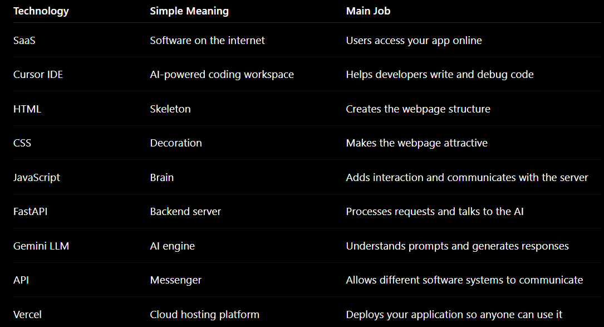
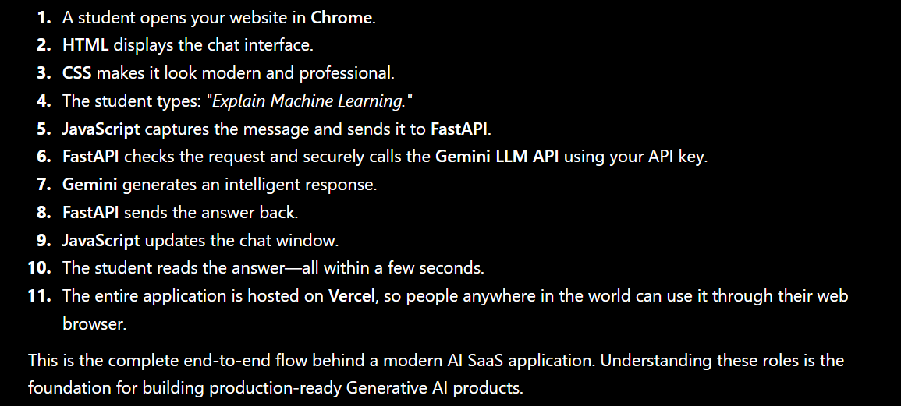

1ST Testing vercel account
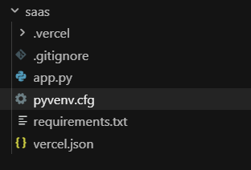
2nd SAAS application Deployment
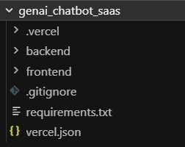
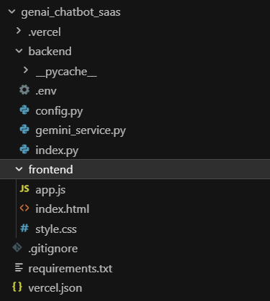
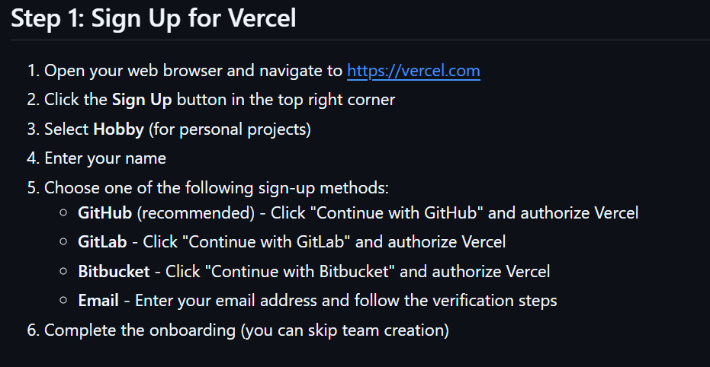
Login to vercel.com signup continue with google
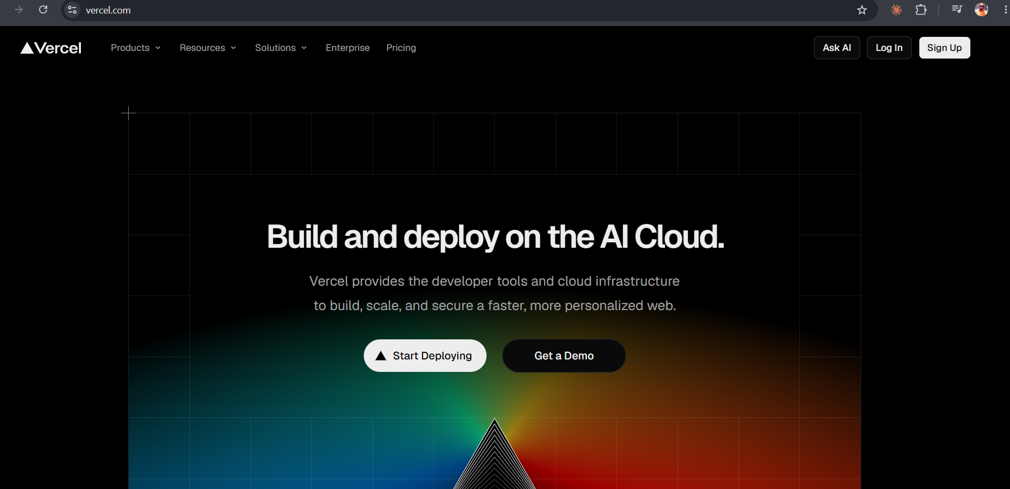
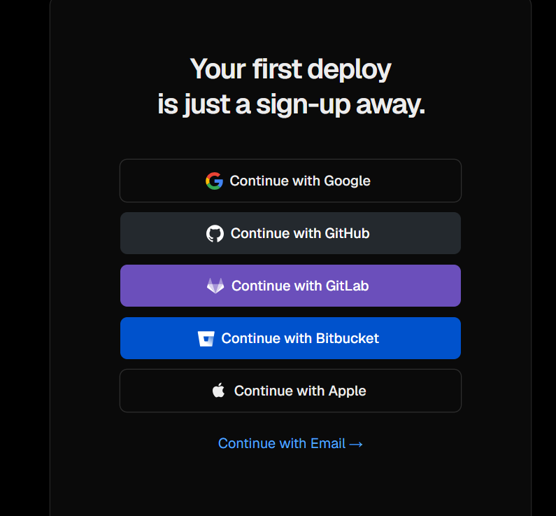
After login with google account below screen will appear continue to github Authorize
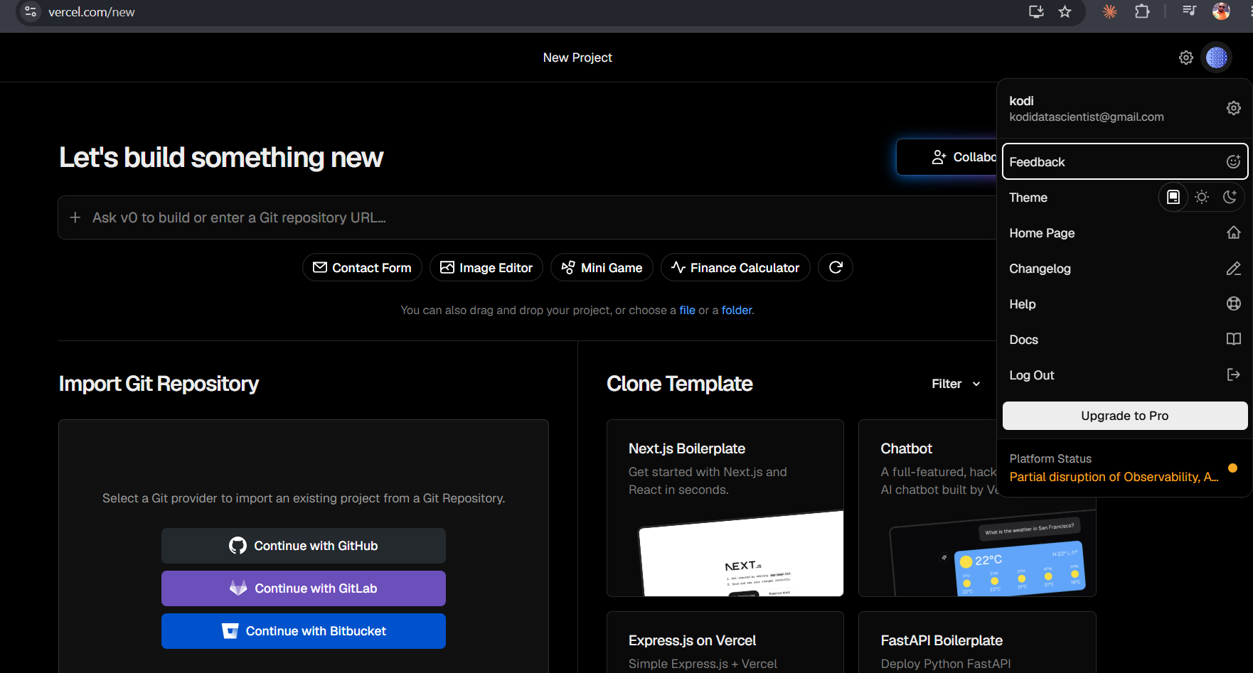

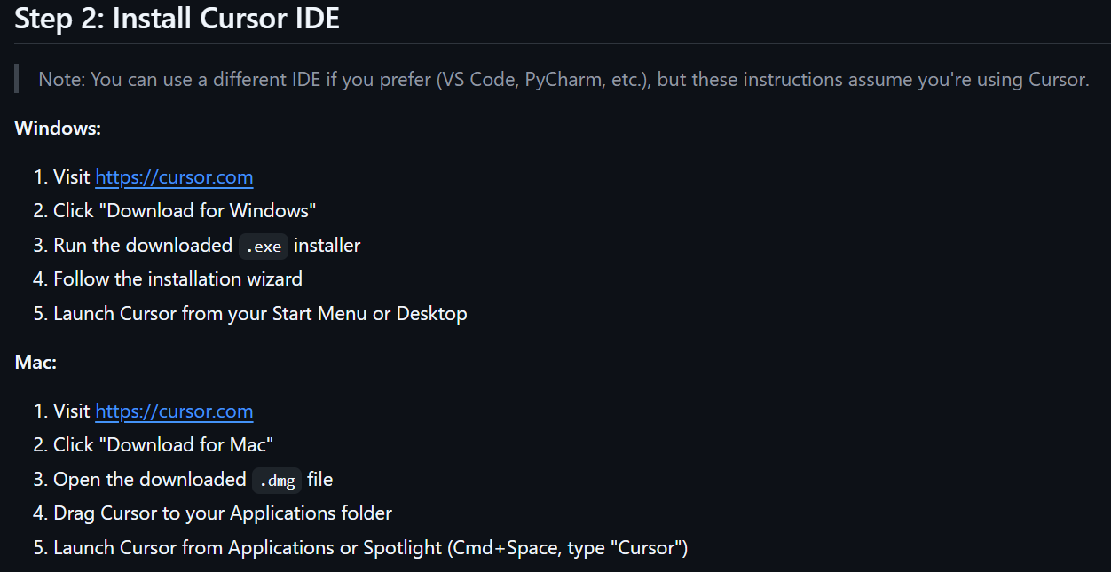
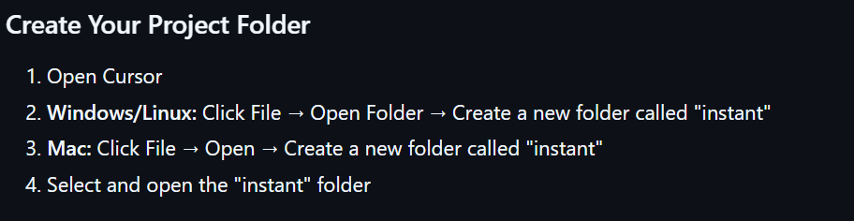
Continue below github link
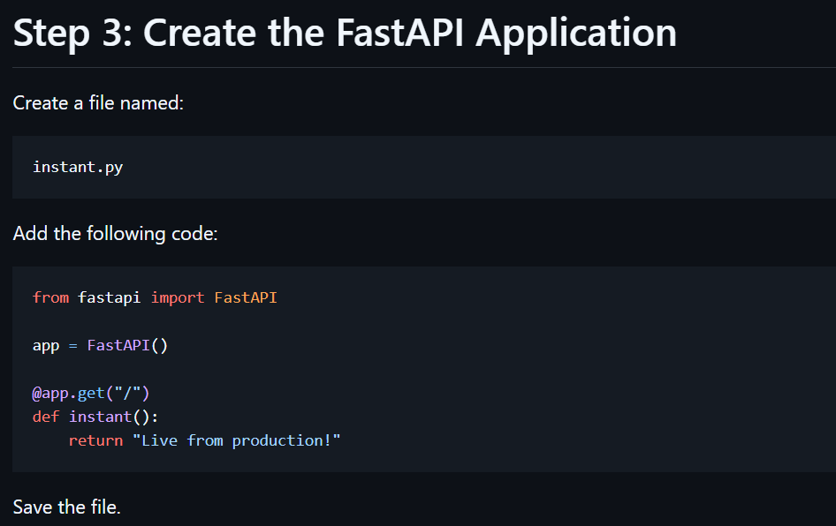
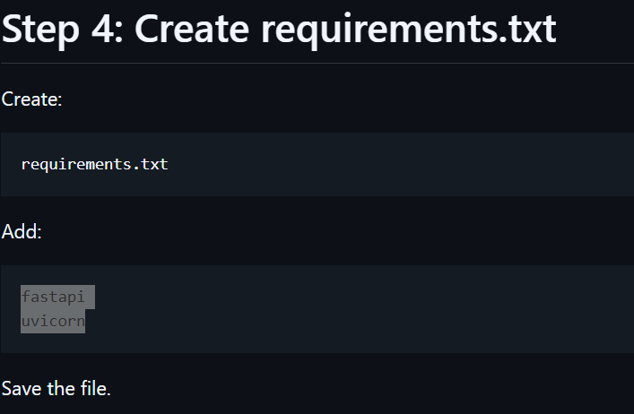
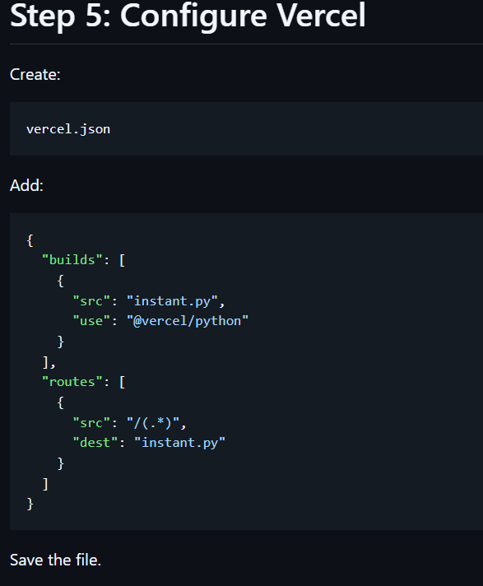
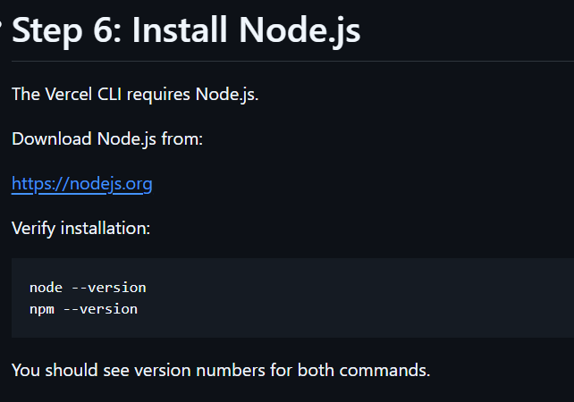
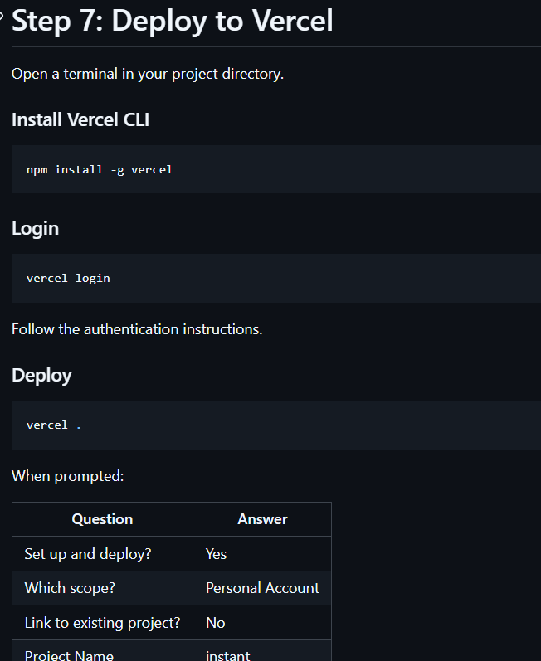

User must go to current folder
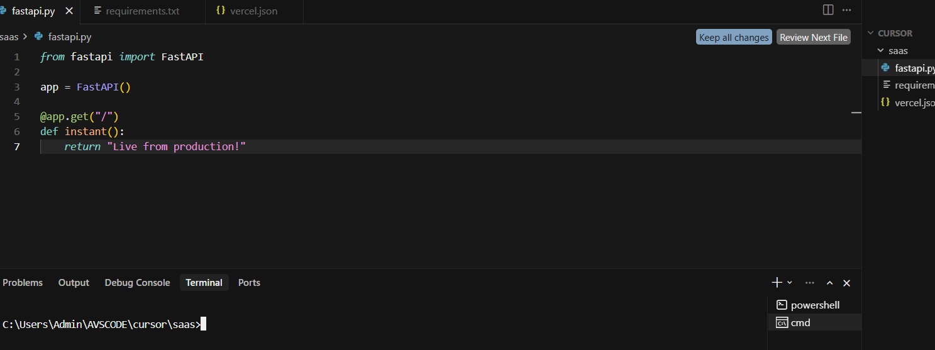
npm install -g vercel user need to come out of folder & then need to install this vercel after install then need to get into the folder

======= EXECUTION STEPS ======
- cd/backend --> uvicorn index:app –reload

- cd/frontend --> index.html
#python -m http.server 5500 (not required)
#web browser you need to write this code --> http://127.0.0.1:5500 ( not required)
- Vercel deployment -->
cmd prompt npm install -g vercel (Vercel login ) ( only for 1st time user only required)
go to the working folder --> everytime vercel login is not required
just type -- vercel
==========================================================================

